Bestiary Schedule

Jellyfish (Small) Lev 1 w/e 09/02/01
Description | Effectively ammo for the net. The first Jellyfish is visible to SB; their colors portray their strength - which in turn determines the power they provide to the Jellyfish Launcher.
Movement Pattern | These Jellyfish can re-spawn once the player has caught them, they can swim in any direction away from the player along the screen following their own set travel path.
Movement Speed | Slow
Attack Pattern | This Monster will only defend himself if SB collides by failing to catch them with the net.
Attack Strength | 20
Attack Type | Shock
Vulnerability | Catch In Net, Shot from Net, Coral Blower, Jellyfish Launcher.
Constitution | 1

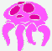
. Name: Jelly Fish (Small) Level 2 w/e 09/02/01

Description | Effectively ammo for the net. The first Jellyfish is visible to SB; their colours portray their strength – which in turn determines the power they provide to the Jellyfish Launcher.
Movement Pattern | These Jellyfish can re-spawn once the player has caught them, they can swim in any direction away from the player along the screen following their own set travel path.
Movement Speed | Slow
Attack Pattern | This Monster will only defend himself if SB collides by failing to catch them with the net.
Attack Strength | 40
Attack Type | Shock
Vulnerability | Catch In Net, Shot from Net, Coral Blower, Jellyfish Launcher
Constitution | 2

Name: Jelly Fish (Large) moving platforms w/e 09/02/01

Description | 3 x the size of the small jellyfish, these wobbly creatures act as moving platforms for the player to jump on.
Movement Pattern | Along a ‘ping-pong’ path these large jellyfish float along for the player to use as moving platforms. Up / Down / Left / Right. They can also be set to do a circuit or to ping-pong diagonally.
Movement Speed | Very Slow – Slow
Attack Pattern | The player should watch out for the stinging tendrils that hang beneath the body. If shocked SB will lose half his health.
Attack Strength | 60
Attack Type | Shock
Vulnerability | None
Constitution | N/A

Name: Anemone Level1 w/e 09/02/01

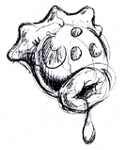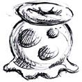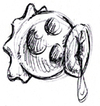
Description | Swollen, bulbous anemones that inhabit all of the levels that effectively acting as sentry turrets spewing projectiles at the player. These creatures can be found clinging to walls, floors and ceilings.
Movement Pattern | Static (fixed)
Movement Speed | N/A
Attack Pattern | Rotates around a 45°, and fires projectiles directly at a target
Attack Strength | 20 per projectile
Attack Type | Projectile
Vulnerability | Shot from Net, Coral Blower, Jellyfish Launcher, Karate Chop, Butt Bounce
Constitution | 1

Name: Anemone Level 2 w/e 09/02/01

Description | Swollen, bulbous anemones that inhabit all of the levels that effectively acting as sentry turrets spewing projectiles at the player. These creatures can be found clinging to walls, floors and ceilings.
Movement Pattern | Static (fixed)
Movement Speed | N/A
Attack Pattern | Expands in size releasing 5 sharp barbs in a 180’ radial blast. The creature then shrinks, waits and repeats the process
Attack Strength | 20 per projectile
Attack Type | Projectile
Vulnerability | Shot from Net, Coral Blower, Jellyfish Launcher, Karate Chop, Butt Bounce
Constitution | 2

Name: Anemone Level 3 w/e 09/02/01
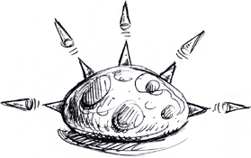

Description | Swollen, bulbous anemones that inhabit all of the levels that effectively acting as sentry turrets spewing projectiles at the player. These creatures can be found clinging to walls, floors and ceilings.
Movement Pattern | Static (fixed)
Movement Speed | N/A
Attack Pattern | Spews noxious gas clouds. The creature then shrinks, waits and repeats the process.
Attack Strength | 20 per sec gas radius
Attack Type | Gas
Vulnerability | Shot from Net, Coral Blower, Jellyfish Launcher, Karate Chop, Butt Bounce
Constitution | 3

Name: Clams w/e 16/02/01
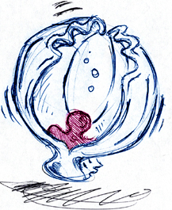

Description | A large foreboding shell that lays dormant until woken at which point it will snap at the player, trying to swallow him.
Movement Pattern | Static
Movement Speed | N/A
Attack Pattern | Proximity triggered by player. At which point they jump and bounce snapping at the heels of the player. Some clams will be pre fixed acting as a sentry but still activated in the same way.
Attack Strength | 20 (can ensnare player - FATAL)
Attack Type | Normal Hit / Swallow
Vulnerability | Shot from Net, Coral Blower, Jellyfish Launcher, Karate Chop (These will shut tight once attacked correctly, leaving them to create an added height advantage for the player to use.)
Constitution | N/A

Name: Squid Darts (small) w/e 16/02/01
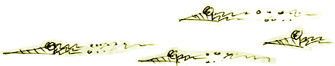
Description | These deadly creatures are spinning molluscs with tendrils streaming behind them.
Movement Pattern | They appear on screen flying in formation swimming directly across the field of view.
Movement Speed | Fast
Attack Pattern | As movement pattern – SB is attacked when he steps into their path.
Attack Strength | 20
Attack Type | Normal Hit
Vulnerability | A well-timed Butt Bounce / Karate Chop will take out an individual Squid Dart but could prove fatal if timed wrong. Projectile attacks should prove a better way of disposing of these creatures.
Constitution | 1

Name: Prickly Bug w/e 16/02/01

Description | Brightly coloured sea slug that crawls slowly along the sea bed.
Movement Pattern | They appear on screen flying in formation swimming directly across the field of view.
Movement Speed | Very Slow – Slow.
Attack Pattern | Poisonous hairs that irritate the player if contact is made with the bug.
Attack Strength | 20 health per second and swapped controls
Attack Type | Poison
Vulnerability | Shots from the Net, Jellyfish Launcher, a projectile from the Coral Blower will turn creature around
Constitution | 3

Ball Blob w/e 16/02/01

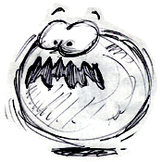
Description | Circular transparent blobby bubble that bounces around like a slow moving bubble – press attack button to repeatedly escape.
Movement Pattern | Bounces diagonally around the screen reflecting off objects.
Movement Speed | Medium
Attack Pattern | This Monster will swallow SB and swim up from the playing field.
Attack Strength | 20 health per second inside creature.
Attack Type | Swallow
Vulnerability | Any attack will send this creature flying in the opposite direction. Using the Coral Blower the player will be able to suck up him up and fire him off. If swallowed the player will have to repeatedly press the attack button, then the Ball Blob will expand and pop releasing the player.
Constitution | N/A

Lurkers w/e 23/02/01

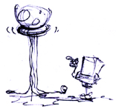
Description | An anemone that hangs down vertically from ceilings with tendrils ready to ensnare and pull up SB.
Movement Pattern | Static
Movement Speed | N/A
Attack Pattern | Triggered by the proximity of the player, the tendrils drop and snare SB.
Attack Strength | 20 per second once SB has reached mouth.
Attack Type | Snare & Swallow
Vulnerability | Shots from the Net, Jellyfish Launcher, Coral Blower. If swallowed the player will have to repeatedly press the attack button, the Lurker will expand and pop releasing the player.
Constitution | 3

Sea Snake w/e 23/02/01
Description | Long and lithe, this snake creature will reflect the colours of the background.
Movement Pattern | Swims along a set ping-pong path
Movement Speed | Medium
Attack Pattern | Contact with the snake will cause it to pass a pulse of electricity through SB
Attack Strength | 20
Attack Type | Shock
Vulnerability | Shots from the Net, Jelly Launcher, Coral Blower
Constitution | 4

Puffa Fish w/e 23/02/01

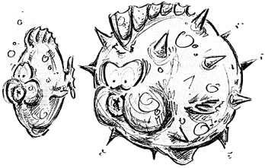
Description | This strange fish puffs up when anyone approaches it blocking the path of the player.
Movement Pattern | Swims along a set Ping Pong path close to the ground
Movement Speed | Slow - Medium
Attack Pattern | Will puff up when player approaches, blocking their path. Contact with the fish will injure SB
Attack Strength | 20
Attack Type | Normal Hit
Vulnerability | Shots from the Net, Jelly Launcher, Coral Blower
Constitution | 5

Angler Fish w/e 23/02/01

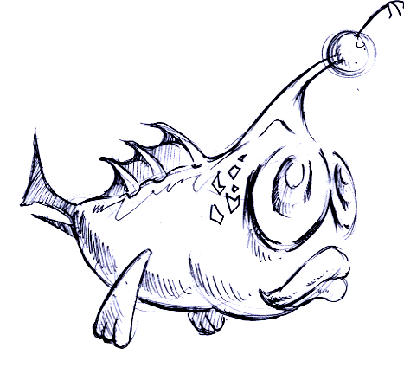
Description | A light dangling in front of this ugly looking fish lights up the world around him.
Movement Pattern | Travels along a set path guiding SB through murky waters.
Movement Speed | Medium
Attack Pattern | They do not attack but if the player does not follow the guide he will find himself lost in a dark oblivion.
Attack Strength | N/A
Attack Type | N/A
Vulnerability | N/A
Constitution | N/A

Spider Crabs w/e 02/03/01

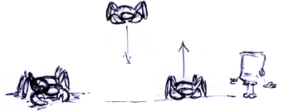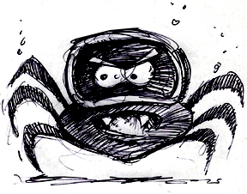

Description | Small crabs that (strangely enough) look a little like spiders.
Movement Pattern | Scuttle around the floor of the seabed leaping over and on top of the player.
Movement Speed | Fast
Attack Pattern | Jump on SB’s Head and pinch him with their pincers.
Attack Strength | 20
Attack Type | Snap
Vulnerability | Shot from Net, Coral Blower, Jellyfish Launcher, Karate Chop, Butt Bounce will flip a crab onto its back – it is unable to move for a set time after which it can flip back. If however once flipped SB attacks again then the crab is terminated.
Constitution | N/A

Nautilus w/e 02/03/01

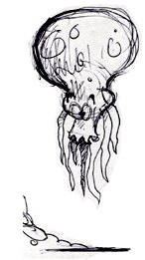
Description | An octopus type creature but with added protection of a shell.
Movement Pattern | Moves around the screen following a set path.
Movement Speed | Medium - Fast
Attack Pattern | Homes in on the player once in a certain radius. The tendrils lash and fire ink.
Attack Strength | 20
Attack Type | Normal Hit
Vulnerability | Using the net, Jelly Launcher or Coral Blower the player can render the Octopus stunned. A karate chop has the same effect but not as strong and the monster will spin off.
Constitution | N/A

Hermit Crab w/e 02/03/01

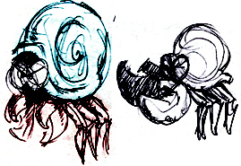
Description | Crabs with a magnificent shell and a huge pair of pincers.
Movement Pattern | Scuttle along the sea bed on a set path.
Movement Speed | Medium - Fast
Attack Pattern | They can perform a pincer attack or box punch roll on the shell.
Attack Strength | 20 (snap) 40 (roll)
Attack Type | Snap / Normal Hit
Vulnerability | One hit returns them to their shell
Constitution | N/A

Booger Monster w/e 02/03/01

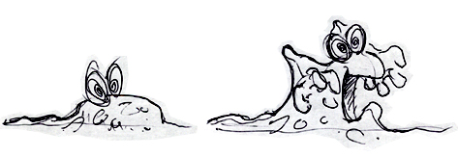
Description | On some of the slimy platforms that the player jumps on, eyes will appear and the platform rises revealing a slimy Booger Monster.
Movement Pattern | Static
Movement Speed | N/A
Attack Pattern | Slows the player down and starts to bite.
Attack Strength | 20 per second in grasp
Attack Type | Snap
Vulnerability | SB will have to try and jump away from them by rapidly hitting the jump button
Constitution | N/A

Skulls w/e 02/03/01
Description | Jump around the screen stomping down heavily on the ground.
Movement Pattern | Bounce around the screen
Movement Speed | Medium
Attack Pattern | Squish SB if he is unlucky enough to be caught underneath one of their bounces.
Attack Strength | 20
Attack Type | Squash
Vulnerability | Any hit will send them bouncing in the opposite direction.
Constitution | N/A

Flaming Skulls w/e 02/03/01

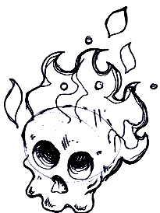
Description | Hanging from the ceiling these horrible creatures will swoop down to attack SB and then return to their perches.
Movement Pattern | Static until attack
Movement Speed | Fast
Attack Pattern | Home in on the player once within a certain radius
Attack Strength | 20
Attack Type | Burn
Vulnerability | Jellyfish Launcher or Coral Blower will explode the projectiles.
Constitution | 1

Eyeballs w/e 09/03/01
Description | Big grotesque eyeballs planted firmly on top of a tall stalk.
Movement Pattern | Static until attack
Movement Speed | Fast
Attack Pattern | Home in on the player once within a certain radius
Attack Strength | 20
Attack Type | Projectile
Vulnerability | Jellyfish Launcher, Coral Blower, Karate Chop, Bum Bounce at the stalk (not the eyeball)
Constitution | 2

Skeletal Fish w/e 09/03/01

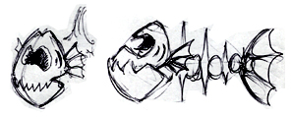
Description | Skeletal Fish that’s found in the barren, dead world. Normally found in small shoals scavenging for a live meal.
Movement Pattern | Swim from left to right of the screen along their own set travel path.
Movement Speed | Fast
Attack Pattern | These skeletal creatures are triggered when the player crosses their line of sight then they turn and attack the player, aiming straight towards them.
Attack Strength | 20
Attack Type | Bite
Vulnerability | Jelly Launcher, Coral Blower, Karate Chop, Bum Bounce will stun the creature. A special type of jellyfish is required to kill the creature.
Constitution | 1

Baby Octopus w/e 09/03/01
Description | Ghostly Pirate that is twice the size of SB!
Movement Pattern | Static (hidden initially)
Movement Speed | Medium
Attack Pattern | The player triggers this ghostly adversary when they enter a certain radius. The pirate and appears and disappears in and out of the floor, at first firing gooey plasma balls and then swiping with his ghostly sword as SB gets closer.
Attack Strength | 20 (projectile) 40 (sword)
Attack Type | Normal Hit
Vulnerability | By using the Net, the Coral Blower or the Jellyfish Launcher to catch the plasma ball they can be used as a weapon against him.
Constitution | 10

Description | A bulbous lump with many tentacles
Movement Pattern | Follows a set path on the screen
Movement Speed | Medium
Attack Pattern | The octopus will use his tendrils to lash out and fire ink at SB.
Attack Strength | 20
Attack Type | Normal Hit
Vulnerability | Using the net, Jellyfish Launcher or Coral Blower the player can render the Octopus stunned. A Karate Chop or Butt Bounce has the same effect but not a strong.
Constitution | N/A

Ninja Starfish w/e 09/03/01
Description | Deadly pointed starfish trained in the art of ninjitsu
Movement Pattern | Static (until attack)
Movement Speed | Medium
Attack Pattern | Will move towards SB homing in on him. Will then stick to SB and drain all his health.
Attack Strength | FATAL
Attack Type | FATAL
Vulnerability | One swipe from the net or a projectile from the coral Blower or Jellyfish Launcher will make them disappear.
Constitution | 1

Water Beanies Level 1 w/e 09/03/01

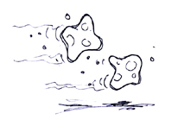
Description | Poisonous liquid blobs with eyes, which drop from the ceiling.
Movement Pattern | Static (until attack)
Movement Speed | Fast
Attack Pattern | Fall from the ceiling under gravity as SB approaches.
Attack Strength | 20
Attack Type | Normal Hit
Vulnerability | Shot from Net, Coral Blower, Jellyfish Launcher, Karate Chop, Butt Bounce
Constitution | 1

Water Beanies Level 2 w/e 09/03/01
Description | Poisonous liquid blobs with eyes, which drop from the ceiling.
Movement Pattern | Static (until attack)
Movement Speed | Fast
Attack Pattern | Fall from the ceiling and home in on SB as he approaches electrocuting him as they attack.
Attack Strength | 20
Attack Type | Shock
Vulnerability | Shot from Net, Coral Blower, Jellyfish Launcher, Karate Chop, Butt Bounce
Constitution | 1

Water Beanies Level 3 w/e 09/03/01
Description | Poisonous liquid blobs with eyes, which drop from the ceiling, twice as big as the previous beanies.
Movement Pattern | Static (until attack)
Movement Speed | Fast
Attack Pattern | Fall from the ceiling and home in on SB as he approaches electrocuting him as they attack.
Attack Strength | 40
Attack Type | Shock
Vulnerability | Shot from Net, Coral Blower, Jellyfish Launcher, Karate Chop, Butt Bounce
Constitution | 1

Zombie Fish Folk w/e 16/03/01
Description | Members of the Fish Folk population that have been turned to ghastly zombies.
Movement Pattern | Follows a set path along the seabed.
Movement Speed | Slow
Attack Pattern | Will injure SB upon normal contact (player should keep out of their way or attack them)
Attack Strength | 20
Attack Type | Normal Hit
Vulnerability | A Butt Bounce or Karate Chop will weaken the ghoul but a shot from the Jellyfish Launcher or Coral Blower will ensure they dissolve into gas.
Constitution | 1

Ghosts w/e 16/03/01
Description | Ghostly!
Movement Pattern | Move along a set path
Movement Speed | Medium
Attack Pattern | If a ghost touches SB he will be injured.
Attack Strength | 20
Attack Type | Normal Hit
Vulnerability | None
Constitution | N/A

Shark Man w/e 16/03/01

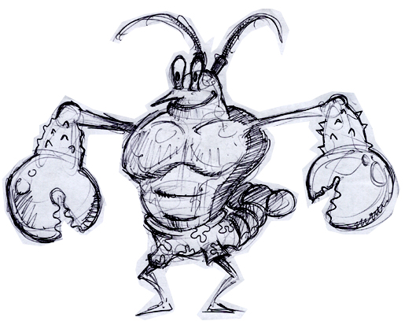
Description | A man with big teeth and fins - larger than player.
Movement Pattern | Travels along a set path
Movement Speed | Fast
Attack Pattern | Charges straight at player once in their field of vision.
Attack Strength | 20
Attack Type | Bite
Vulnerability | Shot from Net, Coral Blower, Jellyfish Launcher, Karate Chop, Butt Bounce, but only vulnerable when facing away.
Constitution | 1

